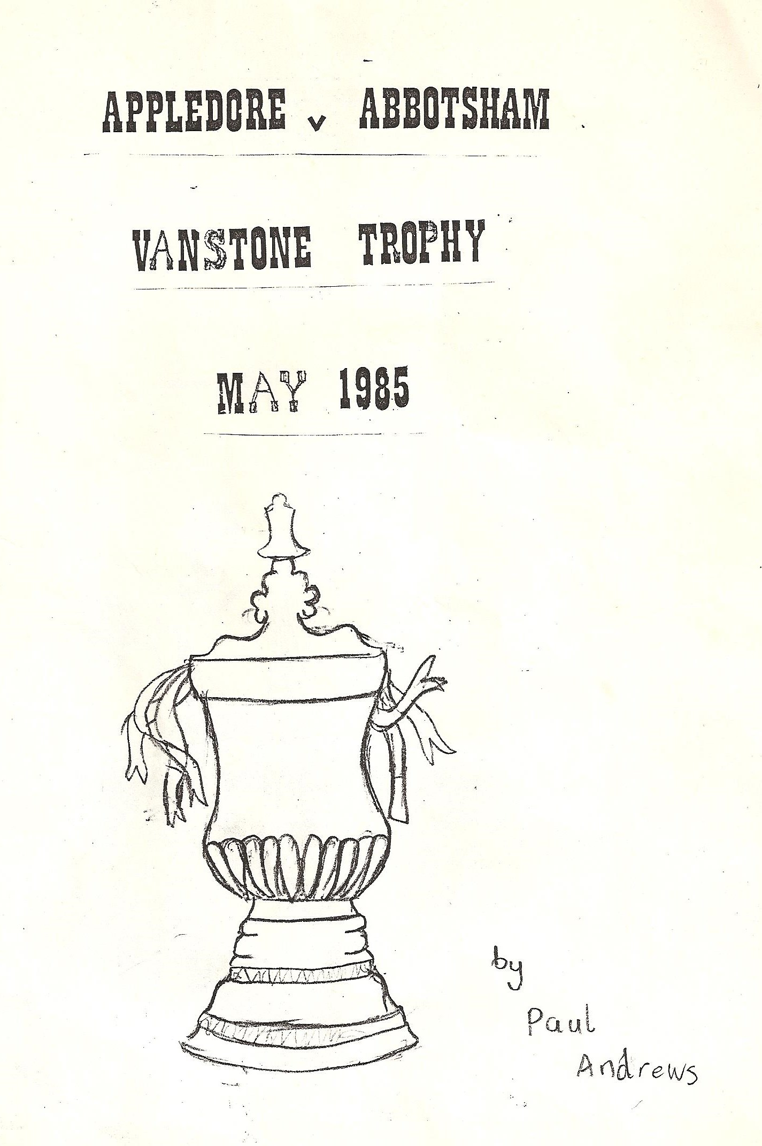
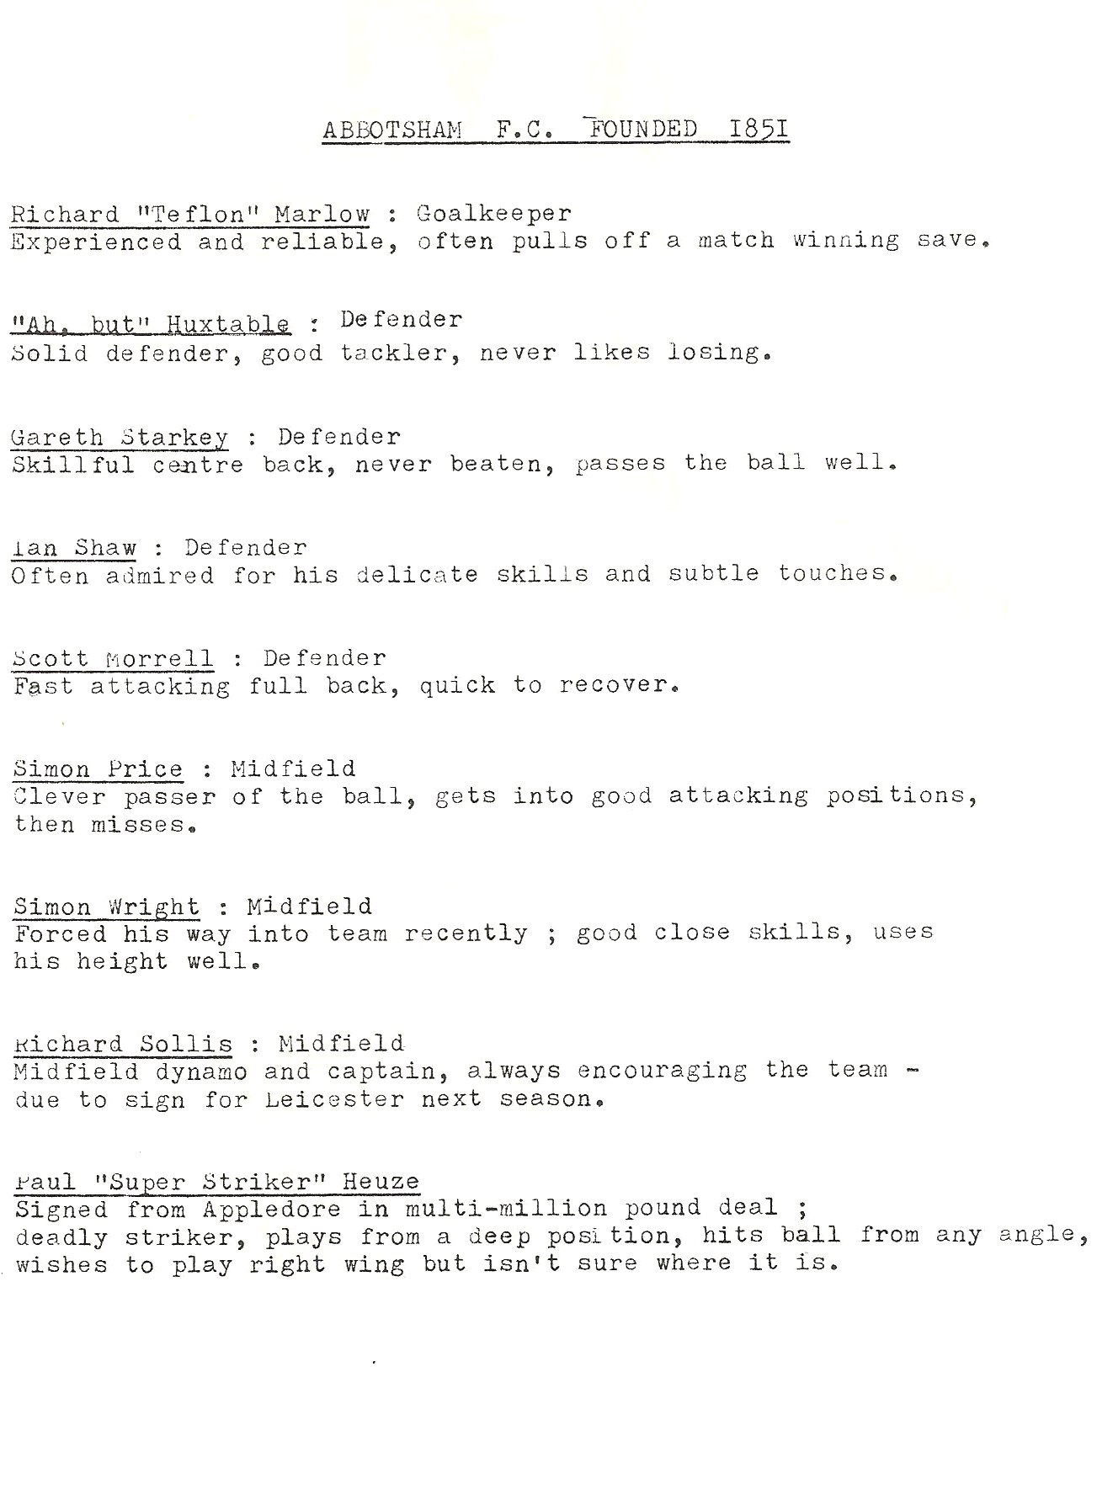
It is believed that the programme notes were written by Nigel Sutton. Note that Scott was a Horrell not a Morrell

